39.8: Combining Equations 37.38 and 37.39 gives
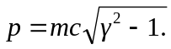
a) 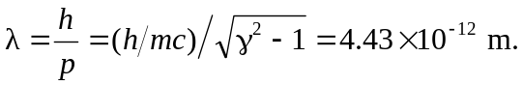 (The incorrect nonrelativistic calculation gives 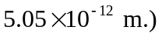
b) 